**March Particle Tracer Test in WLD Working Plan**

**SUMMARY OF PRE-PALLET TASKS**

1. Open, inventory, and organize all shipments (inventory just orange items; no need to do so for pallet). Is anything on this list missing? Make note of missing items and contact Laurel. (Organize by “station.”) Please use a sharpie to label “ESDL” or “Larsen” on major items shipped to LSU so that we don’t get them confused with Twilley lab items in the end.
2. Home Depot trip. Also visit their rental section and inquire about a generator rental starting Tuesday.
3. Cut and prepare the wood pieces that go atop the flume, which you will purchase from Home Depot. Cut them to 5’ to be on the safe side, for those pieces that will be mounted to new aluminum posts. Two of the 8’ boards should be cut to 4’, resulting in four four-footers. These will be for the sampling portals.
4. Test the LISST-Floc (to arrive 3/24) and think about how to mount the battery case.
5. Label and organize sample bottles.
6. Locate LSU’s battery chargers
7. Weigh filters for settling analysis

**Once pallet arrives**

1. Start charging all batteries. There is an extra battery charger in the black Pelican case. Don’t forget the Toughbook batteries.
2. Tackle all remaining “Prep Work” items above

**When the Geotech pump rental arrives**

1. Charge the two batteries they shipped. One is in the black Geotech pump case

**Baton Rouge, Tuesday Task:**

1. Rent a Honda generator from Home Depot ([This mod del](http://powerequipment.honda.com/generators/models/eu2000i), not one of the big ones). You can go online and check whether it is available from any given store. Probably easiest to rent from one of the Baton Rouge stores, because then Alex could return it easily.

**Overview of schedule**

Day 1: Arrival, prep in Baton Rouge, trip to Home Depot

Day 2: Prep day 2 in Baton Rouge. Assemble instrument mounts, etc.

Day 3: Set up pumps and instrument mounts in flume 1. If time permits, vegetation clip plot in nearby representative vegetation.

* Install and test centrifugal pumps
* Install particle tracer injection system
* Set up Vectrino mount
* Set up and deploy LISST-FLOC
* Install sample collection ports
* Install synthetic vegetation patches
* Install sediment traps
* Vegetation clip plots

Day 4: Flume experiment 1

* 30 minute injection of particles at flow rate 1
* 30 minutes of monitoring
* 30 minute injection of particles at flow rate 2
* 30 minutes of monitoring
* Preparation for 15N experiment

Day 5: 15N in flume 1, setup in flume 2

Day 6: Experiment in flume 2

Day 7: Extra in case needed

Tasks during particle injection experiments:

Person 1: Monitor injection

Person 2: Operate Vectrino

Person 3: Sample collection and fluorometer

Person 4: Centrifugal pumps, flow rate monitoring, outlet sample collection

Person 5: Runner/as needed

Shipped on pallet

Ordered separately and shipped to LSU

Already at LSU (Twilley’s)

Already at LSU (Larsen’s)

Purchase at grocery store

Purchase at Home Depot

Carried on

**General materials to have on hand**

Toolbox (and LSU’s)

Grabber

Long-handled loppers for clipping vegetation by Vectrino

Mirror on a rod?

Survey tape

Tape measures

Circular saw

Markers (and ours)

Scissors (and ours)

Waders

Box of bolts and fittings

U-bolts (for contingency designs)

Write-in-rain notebooks

Thumb drives

Does LSU have a gas can for generators?

Verify that Alex sets aside circular saw for us

**I. Injection system:**

7 gallon bucket with lid

Drill bits

Plug-in drill

Paint mixer drill attachment

Angle pieces for supports - varying sizes would be ideal, no more than 3’ length

Zip ties

Bungee cords

Masterflex peristaltic pump OR Geopump (TBD)

1 L Plastic graduated cylinder

100 mL plastic graduated cylinder

Na hexametaphosphate

Size 36 tubing

Line source - there are two alternatives set up right now--the PVC with holes and brass fittings. (in action packer)

Support piece for line source - PVC with a T-connector in the center

Additional brass fittings -- shipped from Amazon. These will be needed if the small-size tubing is needed to achieve the 300 mL/min pump rate.

4’ length of ½” PVC - this goes into the top of the T on the support piece

PVC cutter (gray handles, in Pelican case) - for cutting aforementioned piece to 4’.

Hose clamp that fits over this PVC. (outer diameter) = 0.84”) Pick up extras.

Food coloring (for day-before testing)

Tracer particles -- Laurel to FedEx overnight on Saturday or Monday

Large garbage bags (in case of rain) - in Pelican box

Nitrile gloves- in green bag

PVC cement - in Pelican box

Teflon tape - in Pelican box

Two 4’ length 1 x 4

2 x 4 -- cut this at LSU once figure out appropriate length. See #6 in Prep Work below

Saw for cutting grooves in 1 x 4

Circular saw

Car battery - buy or LSU?

Large inverter - from Amazon

Motor mount - from Amazon

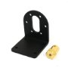

Wood screws for attaching 2x4s together or attaching motor mount to 2 x 4.

Hole saw or other drill bit (for drilling a hole just larger than 0.84 inches. A ⅞” one would be perfect. Something like one of the following pictures)

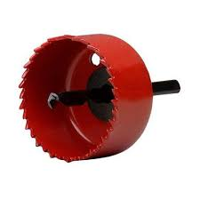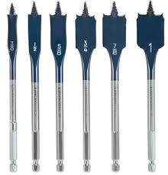

**PREP WORK: (Requires pallet, though wood can be cut and drilled without it--#5 below)**

1. Goal: We need to figure out how to pump the injectate at 300 mL/min. There are two options: A) Use one of the Geotech pumps (black suitcase) (preferred, but I think it’s unlikely that a flow rate that low is possible), or B) Use one of the two Masterflex peristaltic pumps (in the Action Packer).
2. Geotech pump testing: We shipped 1 Geotech pump in the pallet, and another is being rented and will be sent separately. Please try this test on both.
   1. Items needed:
      1. Geotech pump tubing-- this is in the big cardboard box. There are several boxes of tubing in there that are of two different sizes. The big one is the size for the Geotech (It is size 36). I had cut a smaller piece of tubing for testing in the lab, which is in that box. Please use it for your testing, as I want to save the other tubing for the field.
      2. Container for water that you will pump out of--1 L is a good size for the length of tubing I cut.
      3. 1 L graduated cylinder -- shipped from US Plastics, or Alex set aside an additional one.
      4. Stopwatch or phone.
      5. Labeling tape: shipped via Amazon, with additional rolls in the Pelican case, or from Alex
      6. Marker
   2. To connect the tubing, raise the lever on the EZLoad pump head. Sandwich the tubing between the roller bars and the ^-shaped notches on the upper part of the pump head. 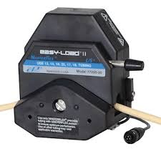
   3. Lower the lever.
   4. Hook up the pump to AC or to the battery.
   5. Adjust the switch that shows the direction of pumping so that it is consistent with what you intend.
   6. With the tube out of the water you will be pumping, turn the pump on. You may need to turn the speed all the way up to start the pump, and then lower the speed to the desired level. Start with the lowest level for your testing.
   7. Once the speed has been adjusted, lower the upstream end of the tubing into the vessel containing water. The other end should be in the graduated cylinder.
   8. Start the stopwatch when water first comes out of the downstream end of the tubing.
   9. Try to find a speed that will deliver 300 mL/minute. If successful, mark the position on the speed dial with labeling tape (i.e., put the tape next to the dial, and draw an arrow to the precise place it should be set).
3. Masterflex peristaltic pump testing (aka “Sample pump”): We have two of these, in the Action Packer. *Only do this if you cannot achieve a 300 ml/min flow rate with either one of the Geotech pumps.*
   1. Items needed
      1. Pump
      2. Cartridges (in a large plastic bag in the Action Packer, or the large cardboard box) 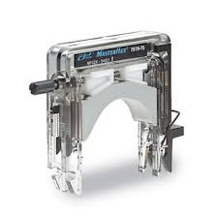
      3. Smaller size tubing - in all of the small tubing boxes within the big cardboard box. (They are all the same). Cut off as small a piece as is needed.
      4. One of the small batteries in the heavy, square battery box
      5. Battery connectors (in a plastic bag in the large cardboard box or the Action Packer)
      6. Container for water that you will pump out of--1 L is a good size for the length of tubing I cut.
      7. 1 L graduated cylinder -- shipped from US Plastics, or Alex set aside an additional one.
      8. Stopwatch or phone.
      9. Labeling tape: shipped via Amazon, with additional rolls in the Pelican case, or from Alex
      10. Marker
   2. Note about cartridges: These are somewhat delicate, and expensive, so use care when handling them. Make sure the two small black knobs on the side are set to “16”.
   3. Align the tubing with the concave part of the cartridge, so that it emerges under the notch on either side.
   4. Hook the left size of the cartridge (in the reference photo above) onto the left rod on the side of the pump. Note that the tubing will get pretty squished down between the rollers and the cartridge, which is normal. Ensuring that the rod stays in place in the cartridge’s groove, lower the other side of the cartridge onto the right-hand rod of the pump head. Depress the lever on the side of the cartridge while seating it over the pump head. Before pushing it until it clicks into place, make sure that the tubing is in the correct position. Here is a [YouTube video](https://www.google.com/url?sa=t&rct=j&q=&esrc=s&source=video&cd=2&cad=rja&uact=8&ved=0ahUKEwjRsbeenevSAhULymMKHWnKBjMQtwIIIDAB&url=https%3A%2F%2Fwww.youtube.com%2Fwatch%3Fv%3DzC1INbSnf8o&usg=AFQjCNHKRsDyaOxvbNF8bD1WD0Aj5vZkOg&sig2=bF3Bm_Oe14NvUh8c_Dq7lw&bvm=bv.150475504,d.cGc), which I suggest you watch once. And here is a photo: 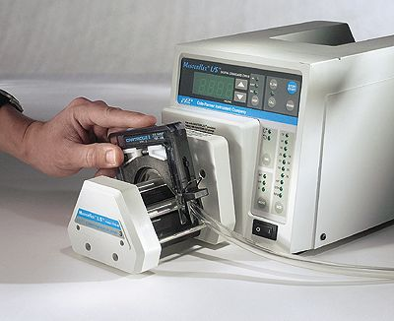
   5. Hook up the battery.
   6. Put one end of the tubing in the vessel you are pumping water out of and the other into the graduated cylinder.
   7. Flip the switch on the front of the pump drive so that it points in the direction you would like to pump.
   8. Flip the power switch on the back of the pump drive up to begin pumping, simultaneous to starting the stopwatch.
   9. Pump for 1 minute and record the volume.
   10. Use labeling tape on the pump drive to write the pumping rate (mL/min) at that speed.
   11. If needed, adjust the speed knob and repeat the test and labeling procedure. Stop when you find the speed that results in 300 mL/min.
   12. Before you undo the assembly, also go ahead and calibrate the flow rate for the sampling station. Here, a rate of 50 mL/min is the target. Use the 100 mL graduated cylinder for this.
4. Next, prepare the line sources. What you do here depends on which pump will create the 300 mL/min flow rate. If you are using the Geotech pump, you only need to glue the fittings that are presently on the PVC. If using the Masterflex pump, you need to switch the brass fittings out for the ones coming from Amazon (while keeping the PVC fittings).
   1. All fittings (brass to brass; brass to PVC; PVC to PVC) need to be permanently attached and free of leaks. The brass-to-brass and brass-to-PVC are screw fittings; PVC-to-PVC fittings are press fittings. There are three fittings (two brass, one PVC) at each point of attachment of tubing and two fittings (PVC) at the end plugs.
      1. For the screw fittings, wrap screw threads with Teflon tape.
      2. Spread PVC cement on top of Teflon on threads and onto the female threads. If dealing with press fittings, spread PVC cement on both sides.
      3. Attach the pieces, ensuring proper alignment. For screw fittings, make sure they are very tight.
      4. Let the entire setup cure for 4 hours.
   2. Prepare the support piece for the line source. This is just the PVC with the T in the middle.
      1. Glue the T.
      2. Cut the 4’ vertical piece that fits into the top of the T, if it hasn’t been done already.
      3. Glue that vertical piece into the T.
      4. Slip the hose clamp onto the vertical piece and tighten it so it won’t fall off. (Vertical position doesn’t matter at this point.)
5. Prepare the point of attachment to the flume: 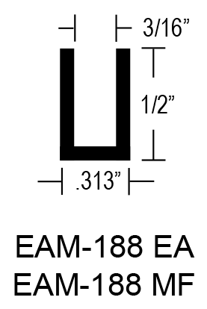
   1. Cut grooves into the two 1 x 4 pieces (one for each flume) that are 1 m apart. Grooves should be of similar width to the ones we cut into the PVC. The width of the C-channel that will sit on top of the flume wall is .313”. The one measurement we had for distance between the inner edges of the plastic was 100.4cm (39.92”), so the channel will decrease that slightly to ~1m (39.37”).
   2. Drill a hole centered between the grooves that the vertical PVC piece will go through. Use the hole saw/hole drill bit you bought.
6. Strategize a method for setting up the drill mixer over the bucket. I’m thinking of potentially bungee-cording a 2 x 4 or one of the angle pieces to the bucket and then attaching the motor mount (if using the 2x 4), which the drill would rest upon (or just supporting it with the angle pieces otherwise). I anticipate using tape or a zip tie to depress the trigger of the drill. It would be nice to use the lid of the bucket, so part of the prep work might involve drilling additional holes in it--one for the mixer, and another for tubing (there may be 2 pieces of tubing coming out of the bucket. Take a look at the photo below from a collaborator for inspiration: 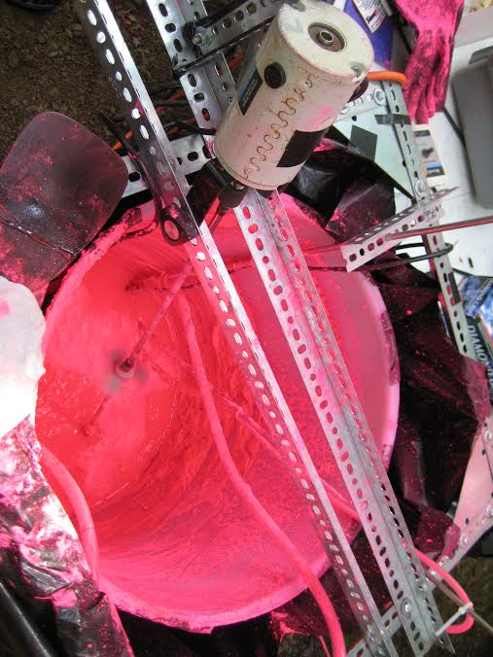

Day of injection:

* Retest flow rate calibration
* The following instructions pertain to two sequential 30 minute injections of particles.
  + Add 9 L of river water to the bucket
  + Add sodium hexametaphosphate to bucket for a final concentration of 5 g/L (for 18 L, this is 90 g.)
  + Add prepared Rhodamine/silt and DTAF/walnut shells to the bucket.
  + Add remaining 9 L of river water to the bucket.
* Connect pump to tubing and deploy line source
* Start mixer

**II. Sampling system**

Materials: The list below is for two per flume.

4’ 1x4 wood for the top of the flume (4)

Narrow threaded rods, 4’ in length (20) -- Note: If you think 4 of these suspended on a 1x4 that goes across the flume will be too heavy, purchase thinner and lighter non-threaded ones instead. At my Home Depot, 5/16 was the only size of threaded rods available in long lengths. *Let’s see if we can pre-order these for store pickup, along with the angle pieces!*

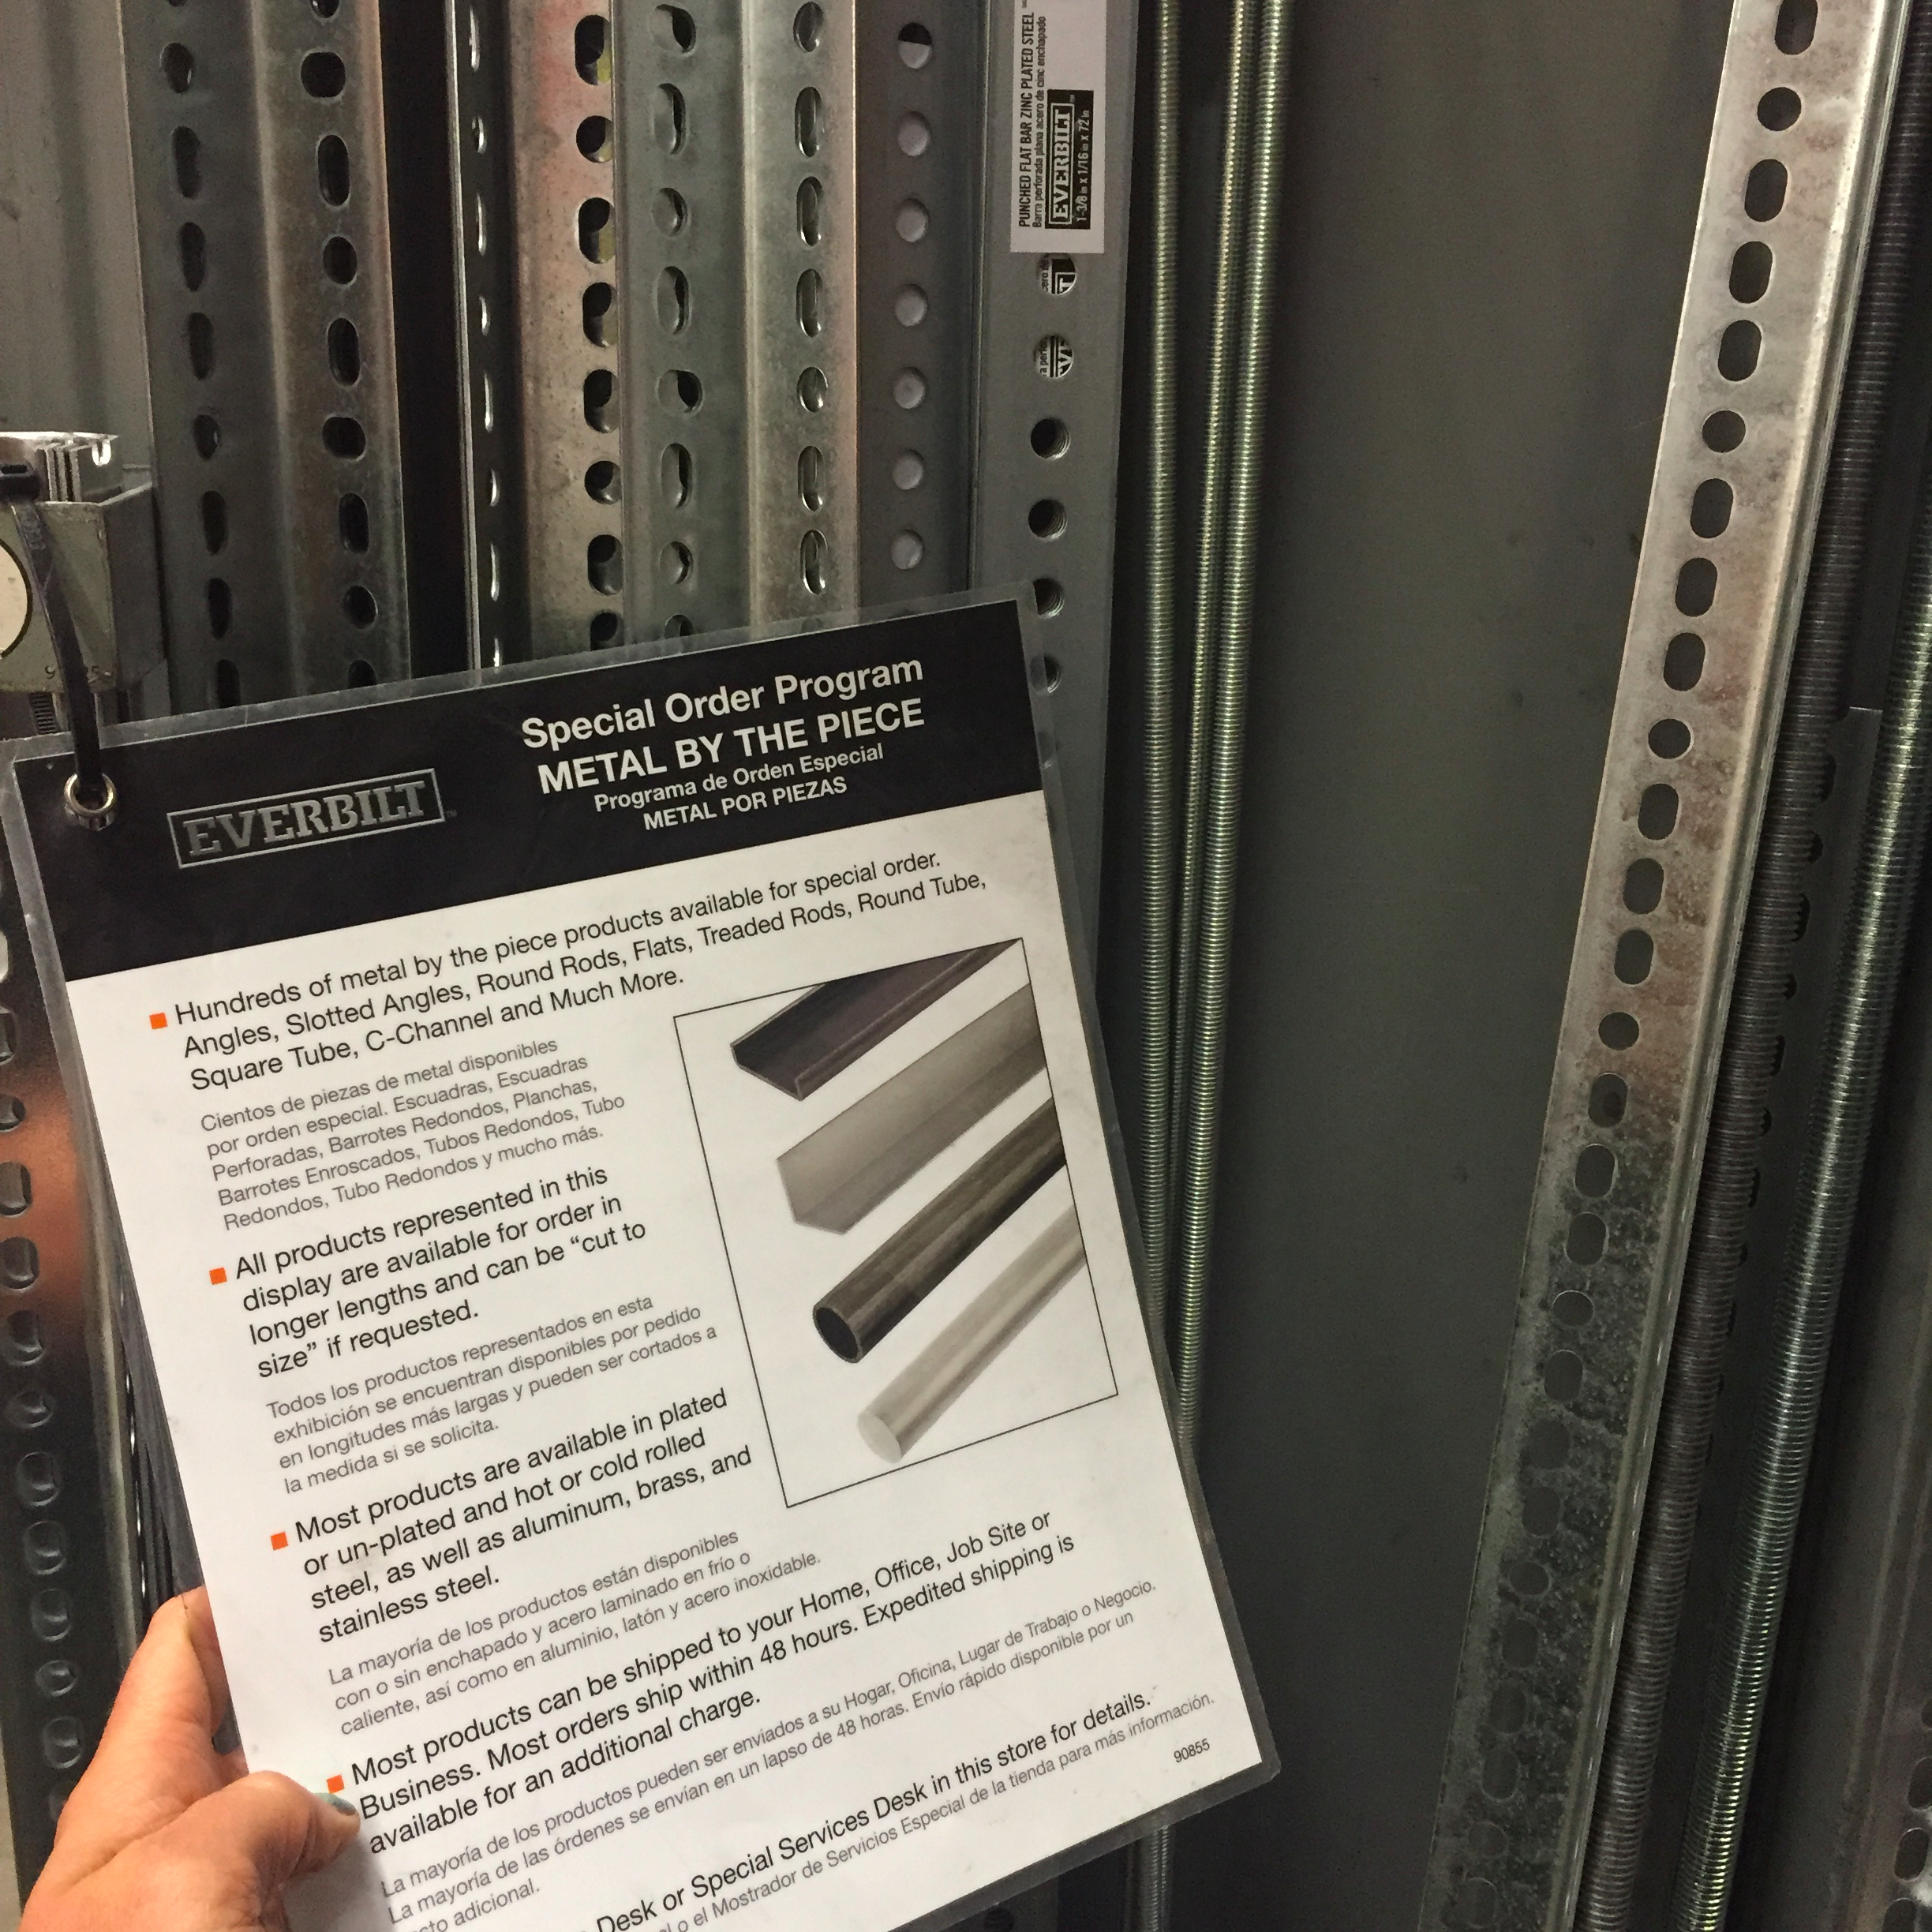

Wing nuts, if using threaded rods. The Bolt Depot box contains 5/16” wing nuts.

Hose clamps that will go over the rods, if using non-threaded rods

Small zip ties - we shipped some, but buy more

Peristaltic tubing - both sizes

Two peristaltic pumps

Pump cartridges

Scissors for cutting tubing

Second Geotech pump and battery

Batteries + extra

Battery cable

20 mL scintillation vials for fluorescence analysis. 8 portals x (40+10)=400 per experiment = 1600 per total week

125 (or was it 150?) mL Nalgenes for particle size analysis

White racks for scintillation vials

1 L Nalgenes (experiment days)

Colorful labeling tape (all colors)

Wooden sampling manifolds (in large cardboard box)

Sample labels

Watch

100 mL graduated cylinder

1000 mL graduated cylinder (experiment days)

Something to put collected Nalgene samples in (we’ll leave the scintillation vials in their boxes)

Duct tape

Drill - pre-tracer day only

Drill bits - pre-tracer day only

Nitrile gloves - experiment day only

**PREP WORK: (Most can get done with just sample vials and sample labels)**

1. Label and organize sample bottles:
   1. Put labels on the 20 mL scintillation vials (fluorescence samples) and 150 mL Nalgenes (particle size samples) in order, following the [instructions](https://docs.google.com/document/d/1HtBt9nNa8KonsAs3MXgB3ZPrRolSvv4MMq9NkgX9QAw/edit?usp=sharing). Keep them organized in the boxes.
   2. If lids are shipped unattached, put lids on.
   3. Use a Sharpie to indicate on the outside of the box the samples that each box contains.
2. Cut grooves in all of the 1x4s that are 1 m apart, as described above for the injection system. No need to drill any holes for the rods yet--this will be done in the field once the final design is finalized.

**Pre-tracer day:**

*Overview:* We will be implementing the following setup:

1. If use Geotech pump at injection site:
   1. Geotech pump 1: At injection
   2. Geotech pump 2: “Upstream site,” just downgradient of injection. Pumps a single portal for particle size. Also pumps samples of injection at beginning and end of experiment.
   3. Masterflex pump 1: Fluorescence at downstream location. There are 6 portals for fluorescence, 4 of which are pumped by this pump.
   4. Masterflex pump 2: Particle size at downstream location (2 portals) and fluorescence (2 portals). Clearly, the particle size sample station needs to be immediately adjacent to fluorescence station!
2. If use Masterflex pump at injection site: Basically a scaled-down version of the above. Result is two fewer ports (i.e., colors) for fluorescence samples. Remove the white (W) and pink (P) portals from the plan above.
   1. Masterflex pump 1: At injection. Also pumps particle size sample from site just downstream of injection.
   2. Masterflex pump 2: Fluorescence at downstream location. 4 portals.
   3. Geotech pump(s): particle size (2 portals). Use lowest setting.

* Measure water level at high and low tide, decide how to set depths of sampling port
* Drill holes for threaded rods and set them at the correct depths
* Attach tubing to threaded rods
* Make sure all lines pump. Measure/set flow rate.
* Color-code the portals with the appropriate labeling tape.

Day of experiment:

* Re-set up pumps and make sure all lines pump
* Collect samples. 30 s first 10 min, 4 min over next 20, 30s next 10, 4 min next 20 or until SCUFA concentrations return to background.
* Also collect samples from water exiting pumps. Do this at plateau, at 10, 14, 18, 22, 26, and 30 minutes

*Sample Schedules:*

1. FD (downstream fluorescence)
   1. BG (background, pre start of experiment)
   2. 0, :30, 1:00, 1:30, 2:00, 2:30, 3:00, 3:30, ….10:00
   3. 14:00, 18:00, 22:00, 26:00, 30:00
   4. 30:30, 31:00, 31:30, ….40:00
   5. 44:00, 48:00, 52:00, 56:00, 60:00
2. FI (injectate fluorescence)
   1. 0, 60
3. FE (fluorescence at flume exit)
   1. 10:00, 14:00, 18:00, 22:00, 26:00, 30:00
4. SU and SD (upstream size and downstream size)
   1. BG (background, pre start of experiment)
   2. 0, 2:00, 4:00...10:00
   3. 14:00, 18:00, 22:00, 26:00, 30:00
   4. 32:00, 34:00, 38:00, 40:00
   5. 44:00, 48:00, 52:00, 56:00, 60:00
5. SE (particle size at flume exit)
   1. 10:00, 14:00, 18:00, 22:00, 26:00, 30:00
6. Add-on: Collect one 1-L bottle of the injectate solution at some point during the experiment. This will be for analysis of the final mass concentration of particles in the injectate. Can be a little less than a liter if needed for the experiments.

**III. Vectrino**

Field laptop

Inverter

Cooler (in case of rain)

Vectrino battery setup

Vectrino

Vectrino mount

Vectrino clamps

Converter box

Vegetation clippers - buy some long-handled ones (like what is used to trim trees) so that we can remove vegetation from the vicinity of the Vectrino from the platform

Two schedule 40 Al pipes

Pipe pounder

Large level

Drill with special bits

Extra drill battery

Bolts to go through sch 40

T-nuts

Wood guide > 1 m to use as level - an extra 1 x 4

Punch

Allen wrench set (metric)

**PREP WORK (Requires pallet).**

1. Use one of the files in the Pelican box to file the groove of the T-slot that the slider is currently installed on, as it catches.
2. Check to see whether the Vectrino can work (all the way to saving a data file) with the Chromebook.
3. Check to see whether the computer (Toughbook) can control the Vectrino and Scufa at the same time.
4. Use a Sharpie to mark a scale on **both** long pieces of 8020 frame. Write a number every 5 cm (you can start with 0 at one end), but note that numbers should match up with the numbers on the tape for the piece on which the slider is already installed. Have ticks for every cm, though a number is only needed every 5. For that piece, we’re just translating the scale over to the side of the frame, since we’ll be standing on the platform and moving it, and it could be hard to see the front. (This view, in the photo below, will be our view from the platform. Here the glued-on measuring tape is on the side of the frame that faces away from the instrument. It will be better to have a measurement scale on the side facing us. 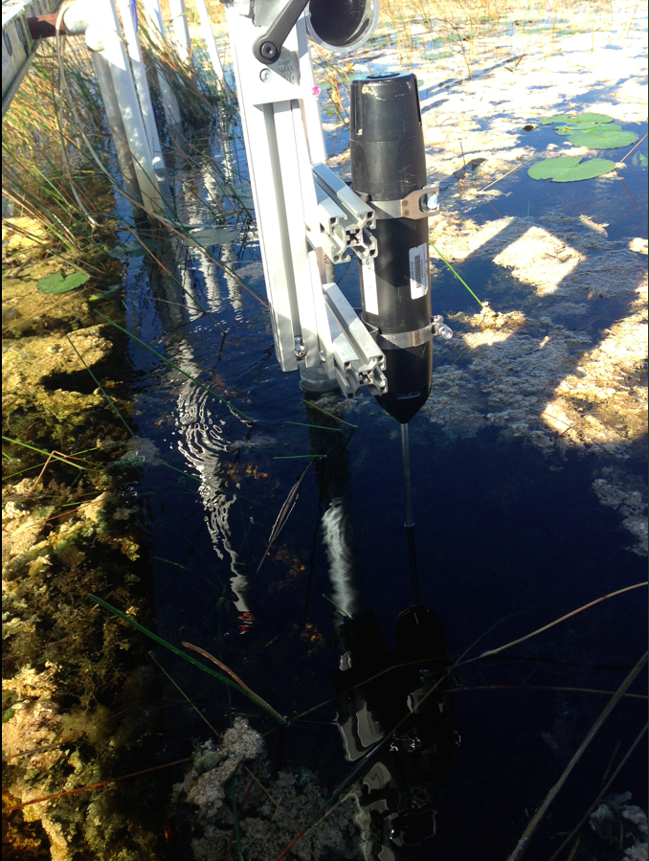
5. Assemble at least some of the Vectrino mounting frame, using the photo above as a guide. There are two metal plates in the divided box of bolts that was shipped, which are used to attach the cross-pieces above. The nuts and bolts needed for this frame are also in that box. Using the multi-hole nuts for the perpendicular attachments will give this frame the most stability. New Vectrino clamps are in the small cardboard box from JEGS, shipped in one of the boxes in the pallet. Those clamps will mount directly to the frame. Laurel will be bringing the remaining pieces to make this vertical mount slide across the width of the flume.

Preparation day (2 people):

* File t-slot (in advance)
* Mark measurement increments on both t-slot frames (in advance)
* Install sch 40 support posts
* Mark posts for angle brackets, ensuring level
* Drill posts and install angle brackets. Bottom one is screwed into a t-nut and left loose.
* Install Vectrino mount and tighten down bottom nuts in angle bracket.
* Pre-assemble Vectrino mount (in advance)

**IV. SCUFA**

Field laptop

SCUFA

SCUFA battery (get 12 V, 4 AmpH)

SCUFA battery connectors

2 Al pipes

1x4 cross piece

Bolts

Drill

Pipe pounder

Rod

Wing nut

Hose clamps (2.5” diameter-but needs to get a little bigger, to accommodate rod. We’ll use these to mount the SCUFA to the rod)

Rubber plumbing coupling: something like this photo, but larger diameter and smaller height, if available. This will go between the hose clamp and the instrument. If unavailable, we’ll wrap the instrument with electrical tape. 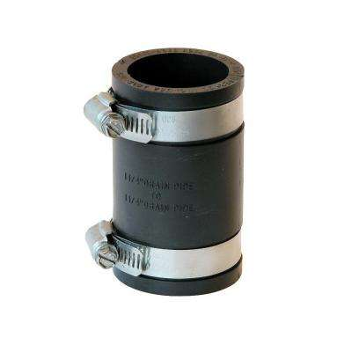

Punch

Preparation day: (2 people, same two as prep the Vectrino)

* Install sch 40 support posts
* Mark posts, ensuring level
* Drill posts
* Drill wooden cross-piece. Need hole in top for mounting rod
* Install SCUFA

**PREP WORK (Does not require pallet).**

1. Cut the 1 x 4. If you think it can just rest on top of the flume, cut grooves in it. If you think it needs to go on separate posts, just cut it to about 4.5’ long.

**V. Site characterization**

Pipe for vegetation quadrats (incl vertical pieces)

Pipe cement

Goggles or mask and snorkel

1 L nalgenes

Small clippers/scissors

Engineer’s rule

Extra piece of PVC, if available

Garbage bags - buy an extra box

**PREP WORK (Does not require pallet)**

Glue the quadrat pieces into a square measuring 0.25 m on each side, accounting for the length of the elbow pieces once the pipe is pushed into them. I may or may not have pre-cut the PVC side pieces. I really do not remember. I think I probably didn’t.

Preparation day (or experiment day):

* Obtain 3 vegetation clip plots.

Experiment day:

* Collect a 1 L Nalgene of water outside the flume before and after the experiment.

**VI. LISST-Floc**

LISST

Clamps (from Sequoia Scientific)

Bolt (from Bolt Depot)

3 aluminum pieces (per flume)

Speedrail fittings

Batteries (from Sequoia Scientific)

Drill

Calibration container

**Tasks (can be done pre-pallet):**

1. Ensure the instrument can be connected to the computer and run. Is there a way you can check the battery life for the installed battery packs? If less than 48 h, we should replace them with the batteries shipped from Sequoia.
2. Perform a calibration with the calibration chamber that was shipped. Refer to the [manual](https://www.google.com/url?sa=t&rct=j&q=&esrc=s&source=web&cd=2&cad=rja&uact=8&ved=0ahUKEwjXuOGAve3SAhXFx1QKHZS3AhsQFgggMAE&url=http%3A%2F%2Fwww.sequoiasci.com%2Fwp-content%2Fuploads%2F2013%2F07%2Fmanual-5.pdf&usg=AFQjCNH72MfQD47L3ZiBfKaQCbAZv2PVLQ&sig2=8vUfl98KIEqh8137oEKu0A) for this.
3. The LISST will be deployed in place vertically for the duration of the experiment. The LISST clamps (shipped from Sequoia Scientific, along with an extra battery pack) will secure the instrument to a vertical aluminum rod, which will be secured to an aluminum frame assembled with speedrail attachments. We need to brainstorm how to attach the battery pack (once we see the instrument). It would be ideal if the cable reached to the platform so that the battery pack could be installed there.

**VII. Direct Interception**

Dowels (3/16” - ¼”), quantity 13

Clear or white silicone grease (in plumbing section)

Nitrile gloves or paper towel

Tupperware boxes for recovery of dowels

Vegetation clippers

Saw (as backup)

**VIII. Settling**

Maddie’s settling setup

**TIDE INFO:**

Two nearby tide sources are Point Chevreuil to the west

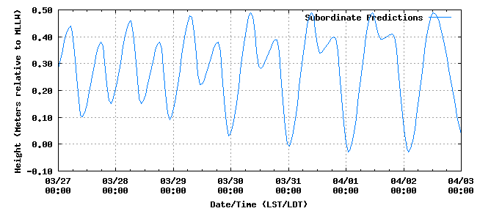

And Amerada Pass to the east

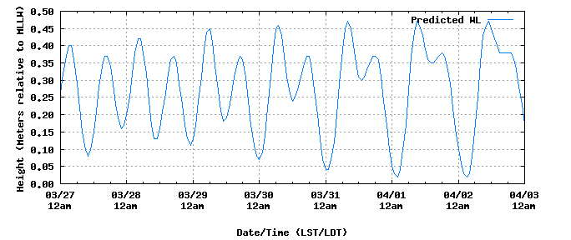

What period in the tidal cycle are you aiming for?

**Personnel and Contact Information**

Laurel Larsen, 510-529-5574. Emergency contact: Carol Griggs, 321-269-0285

Dino Bellugi, 510-813-9306. Arden Fredman (510) 710-8931

Chris Tennant, 828-507-3692; Renee Tennant: (828) 399 - 0575

Alex Christensen, 602-373-2764

Maddie Foster-Martinez, 504-782-2172; Bee Chenier, 225-224-1090 (sister who lives in BR)